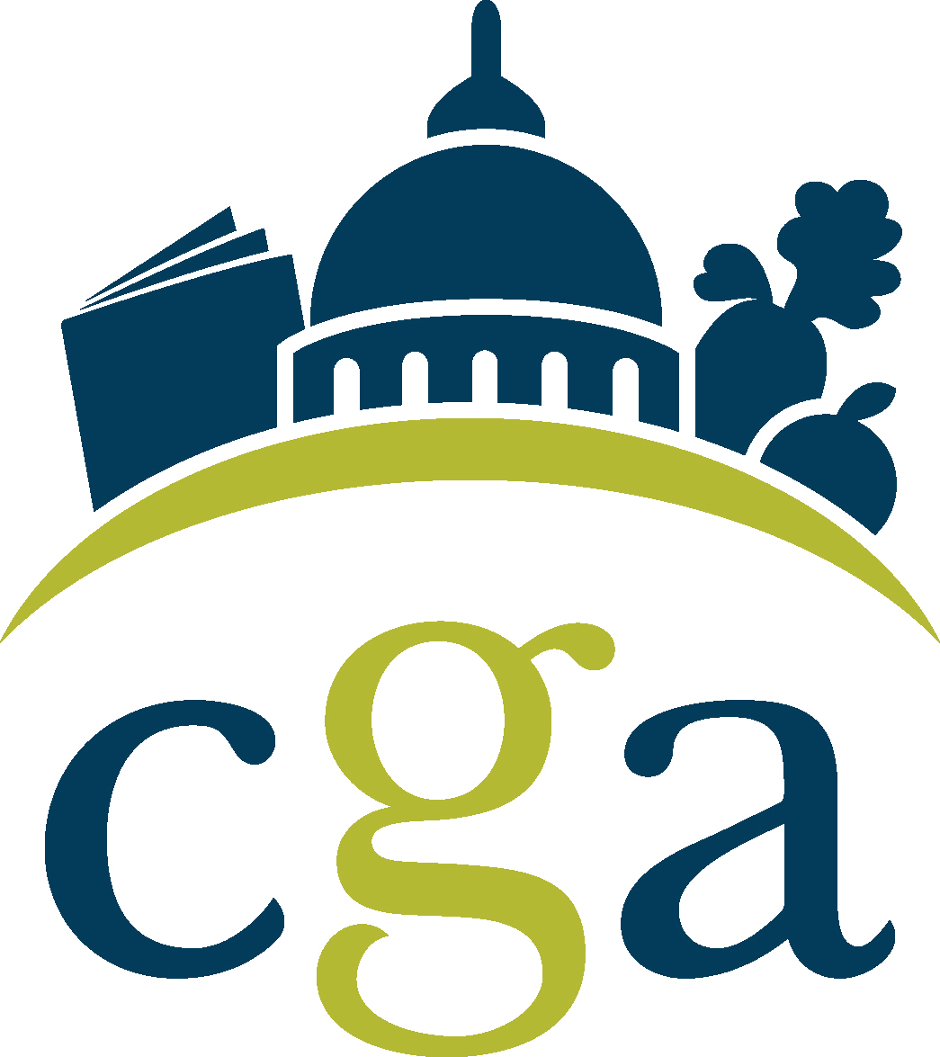

Agenda
CGA Grocers Day
Wednesday, April 6, 2022
Noon – 4:00pm PST
Sacramento, CA

12:00pm – 12:20pm: Lunch

12:20pm – 12:30pm: Welcome & introduction through lunch

12:30pm – 1:15pm: Session 1: The California Republican Direction & Priorities for 2022
Assembly Republican Leader James Gallagher (AD 3)

1:15pm – 2:00pm: Session 2: ‘CA Fair Pay & Employer Accountability Act’ (PAGA) Campaign
Christy Wilson, Wilson Public Affairs

2:15pm – 3:00pm: Session 3: The Governor’s office & Priorities for 2022
Stuart Thompson, Chief Deputy Legislative Secretary for Governor Newsom*

3:00pm – 3:45pm: Session 4: Fireside chat with CGA on Recycling, the budget, & legislative priorities
Assemblymember Phil Ting (AD 19), Budget Chair

3:45pm – 4:00pm: Session 5: All things political: Discussion on CGA PAC & 2022 elections
Kelly Ash (CGA) & Michel LeClerc (GR committee Chair)

We have invited CalRecycle Director, Rachel Wagoner, to speak with us as well.

*invited

