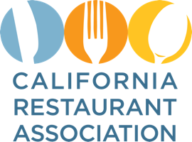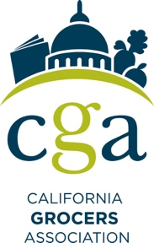

FOR IMMEDIATE RELEASE
March 23, 2020

CONTACT:
Dave Heylen | California Grocers Association | 916-228-4423 DHeylen@cagrocers.com
Sharokina Shams | California Restaurant Association | 916-431-2749 sshams@calrest.org

California Restaurants and Grocers Work to Meet Food Needs During Coronavirus Crisis

California’s food economy relies on two distinct systems for feeding its nearly 40 million residents – traditional grocery stores and restaurants.

In fact, annual food spending is roughly evenly split between the two industries.

With the COVID-19 pandemic reshaping our daily lives, the importance restaurants and grocery stores play in nourishing Californians is more crucial than ever. Restaurants and grocery stores are working day and night to provide meals and other necessities of life.

Ensuring both industries remain open and operating is essential to the health and well-being of everyone now under stay-at-home orders.

“Public officials who’ve issued shelter-in-place orders have wisely made an exception for essential activities outside the home, which include the need to pick up groceries or prepared meals,” said Jot Condie, President and CEO, California Restaurant Association “The need for at-home meals is greater than ever as parents provide more daily meals to children home from school.”

While restaurants have closed their dining rooms, many remain open for drive-thru, delivery, and takeout orders. The grocery industry is working around the clock to move goods through its supply chain and onto store shelves. In addition, grocers are now hiring thousands of additional staff to help with increased demand, many of whom were displaced by the reduction of hours from restaurants.

“California’s food supply is safe and plentiful,” said California Grocers Association President and CEO, Ron Fong. “We encourage Californians to shop smart and not overfill their shopping carts. By doing so, we can keep our shelves stocked.”

Safeguarding our restaurants and grocery stores and ensuring their continued operation will help to diffuse and ease the anxiety and uncertainty of COVID-19, while providing the food needed to sustain life.

Whether you’re looking for the comfort of a well-cooked meal or something that delivers a home-cooked feeling, either a restaurant or bag of groceries will do. Please continue to support both sides of California’s richly famous food economy.

We’re all in this together.

