Situation report

7/29 /18 0930h

Statewide

Fire Summary
Incident Name/County | Acres | % contained | Expected Containment Date | Injuries/  Fatalities | Structures  Threatened | Structures  Damaged | Structures  Destroyed
Carr Fire, Shasta | 89,194 (+5,394) | 5% | 8/10/2018 | 0/5 | 5,012 | 154 (+75) | 613 (+98)
Cranston Fire, Riverside | 13,130 (+12) | 29% (+12%) | 8/9/2018 | 2/0 | 4,927 | 5 | 0
Ferguson Fire, Mariposa | 53,646 (+4,027) | 29% | 8/15/2018 | 7/1 | 5,236 | 0 | 1
Mendocino Complex Fire, Mendocino | 24,270 (+14,770) | 10% (+8%) | 8/5/2018 | 5/0 | 4,587) (+4,201) | 0 | 4 (+2)

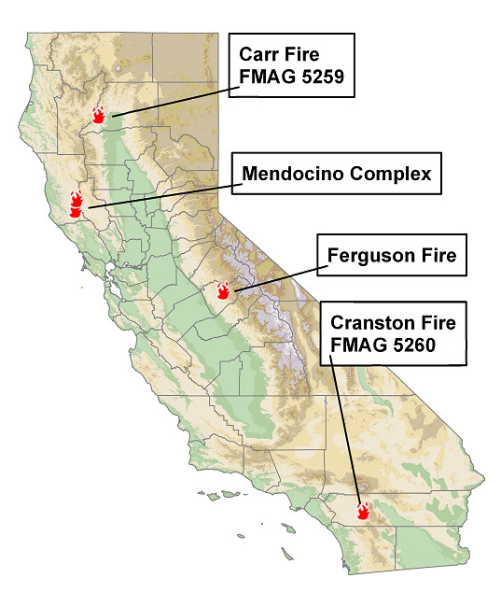
Proclamations/Declarations
Incident Name/County | Local Emergency Proclamation | Governor’s Emergency Proclamation
Carr Fire, Shasta | 7/26/2018 | 7/26/2018
Mendocino Complex, Mendocino | 7/28/2018 | 7/28/2018
Ferguson Fire, Mariposa | 7/15/2018 | 7/26/2018
Cranston Fire, Riverside | 7/25/2018 | 7/26/2018

WEATHER SYNOPSIS

Northern California
Valley | Foothills
High Temps: 100-110 Low Temps: 65-75 | High Temps: 90-100 Low Temps: 55-65
Humidity Day: 5-10 Night: 35-45 | Humidity Day: 25-35 Night: 15-25
Winds: 5-10mph with gusts up to 25mph | Winds: 5-15mph with gusts up to 25mph

*Red flag warning until 0800 on 7/30/18

Southern California
Coast | Inland
High Temps: 85-95 Low Temps: 60-70 | High Temps: 110-115 Low Temps: 70-80
Humidity Day: 30-40 Night: 40-50 | Humidity Day: 10-20 Night: 20-30
Winds: 5-10mph with gusts up to 20mph | Winds: 5-15mph with gusts up to 25mph

*Dust storm warning for winds gusting up to 40mph

Evacuations
Incident Name/County | Mandatory Evacuations | Advisory Evacuations
Carr Fire, Shasta | 34,181 | 0
Mendocino Fire Complex, Mendocino | 750 | 350
Ferguson Fire, Mariposa | 1,444 | 0
Cranston Fire, Riverside | 3,700 | 0

Shelters
County | Name | Location | Type | Status | Count/Capacity
Shasta | Shasta College | 11555 Old Oregon Trail, Redding | ARC | Open | 600 (+79)/  600 (+79)
Shasta | Crosspoint Community College | 2960 Hartnell Ave, Redding | ARC | Open | 93 (+13)/253
Shasta | Simpson University | 2211 College Dr, Redding | ARC | Open | 72/135
Shasta | Grace Baptist Church | 3782 Churn Creek Rd, Redding | Ind. | Open | Pending/200
Shasta | Foothills High School | 9733 Deschutes Rd, Palo Cedro | ARC | Open | 0/300
Trinity | Trinity High School | 321 Victory Lane, Weaverville | ARC | Open | 32/172
Tehama | Rolling Hills Casino | 2655 Everett Freeman Way, Corning | Ind. | Open | 150/150
Trinity | Weaverville Elementary | 234 Trinity Lakes Blvd, Weaverville | ARC | Closed | 0(-21)/50
Mariposa | Mariposa Elementary School | 5044 Jones St, Mariposa | Unknown | Open | 19(+2)/100
Riverside | Banning High School | 100 W. Westwood Ave, Banning | Unknown | Open | 50(+3)/175
Riverside | Hamilton High School | 57430 Mitchell Rd, Anza | Unknown | Open | 0(-21)/240
Lake | Mountain Vista Middle School | 5081 Konocti Rd | ARC | Open | 145/104
Mendocino | Mendocino College | 1000 Hensley Creek Rd, Ukiah | County | Open | 26/83
Lake | Twin Pine Casino | 22223 CA-29, Middletown | ARC | Open | 5/170
TOTAL |  |  |  |  | 1,042(+185)  /2,732(+111)

Animal Shelters
County | Name | Location | Status | Animal Types | Count | Notes
Shasta | Trinity Animal Control | N/A | Assisting | All | Unknown | Assisting w/ animal sheltering from the first wave of evacs
Shasta | Shasta District Fairgrounds | 1890 Briggs St, Anderson | Open | Unknown | N/A | CALFIRE camp
Shasta | Redding Rodeo Grounds | 715 Auditorium Dr, Redding | Open | Large | Unknown | Unconfirmed – Information from social media, news, and elected officials
Shasta | Haven Humane Society | 9417 Eastside Rd, Redding | Open | Unknown | Unknown | Unconfirmed – Information from social media, news, and elected officials
Shasta | Shasta Livestock Auction | 3917 Main St, Cottonwood | Open | Large | Unknown | -
Glenn | Glenn County Fair | 221 E. Yolo St, Orland | Standby | Small & Large | Unknown | -
Lassen | Lassen County Fair | 195 Russell Ave, Susanville | Standby | Large | Unknown | -
Colusa | Colusa County Fair | 1303 10th St, Colusa | Standby | Small & Large | 0 | -
Mariposa | SPCA of Mariposa County | 5599 CA-49, Mariposa | Open | Small | Unknown | -
Mariposa | Mariposa County Fairgrounds | 5007 Fairgrounds Rd, Mariposa | Open | Large | 50 | -
Mariposa | Coursegold Rodeo Grounds | 44777 Rodeo Grounds Lane, Coursegold | Standby | Large | Unknown | -
Mariposa | Eastern Tri-County Fair | 1234 Sierra St, Bishop | Unknown | Unknown | Unknown | -
Riverside | San Jacinto Valley Animal Campus | 581 S. Grand Ave, San Jacinto | Open | Small | Unknown | -
Riverside | Dysart Equestrian Park | 2101 West Victory, Banning | Unknown | Large | Unknown | -

Critical Infrastructure
Incident Name/County | Utility | Utility Type | Customers Affected | Time to Restoration
Carr Fire, Shasta | Redding Electric | Electric | 650 | Unknown
Carr Fire, Shasta | Pacific Gas & Electric | Electric/Gas | 3886/502 | Unknown
Mendocino Complex, Mendocino/Lake | Pacific Gas & Electric | Electric | 0 (-37,000) | Restored
Ferguson Fire, Mariposa | Pacific Gas & Electric | Electric | 124 | Unknown
Cranston Fire, Riverside | Anza Electric | Electric | 5,200 | Unknown

Shasta County
- Cal ISO
  - Per CUEA: As of 7/29/2018 at 0425, the two 115kV lines that relayed have been restored. All load that can be restored, has been restored. The Northern CA Region Transmission Emergency for the Ukiah local area has ended.
  - Summary of Events
    - Transmission Emergency declared by Cal ISO on 07/28/18 at 2226 hours in Lake and Mendocino counties
    - It is unknown if the outage is due to a tripped transmission line because of the smoke plume or if the line is burned; the cause is however thought to be due to smoke at this time.
    - PG&E crews are currently assessing the situation.
    - The automatic re-set function of the transmission line is off due to fires burning in the area, as if it trips, it could cause additional fires.
    - If the outage is due to smoke, it requires PG&E to manually close the circuit to restore power.
      - If the outage is due to burned transmission line, restoration will be a longer process.

- Dams
- Power Plant Operations: Shasta, Keswick and Trinity power plants are back up and running. Trinity power plant is currently the sole source of electricity for the county. This is a temporary arrangement until the grid is checked and normal electrical distribution resumes. All operating power plants are being staffed 24/7. There is no threat or concern to infrastructure at this time. Additional updates will be provided as information becomes available.
- Spring Creek Detention Dam: Spring Creek Dam impounds toxic seepage from the Iron Mountain Mine Superfund Cleanup Site upstream on Boulder Creek. The Iron Mountain Mine has a 7 million gallon waste impoundment that has plenty of storage capacity left with no concern about imminent releases from Iron Mountain. Spring Creek Detention Dam is nearly empty with most of its storage capacity available. Additionally, BOR has a large amount of water stored for dilution purposes should any waste enter the Sacramento River. There is no concern about either Iron Mountain Mine Superfund Cleanup Site or Spring Creek Detention Dam posing a threat to public safety, environment, or water quality.
- Iron Mountain Superfund Site
  - Iron Mountain has been placed at the top of the priority list for restoration
  - Site is securing fuel for generators for tomorrow.
  - Private fire crew arriving today.
  - Coordinating power restoration crews with CUEA.
  - Concerned about fire status in area surrounding site.
  - Considering restarting treatment plant.
- Sacramento River is currently not in danger from Acid Mine Drainage
- City of Redding – Water Treatment Plant
  - Threat to chlorine cylinders at Clear Creek CSD abated. CalEPA provided recommendations and resources late Friday night regarding safety when in proximity to the treatment plant until better situational awareness was available

