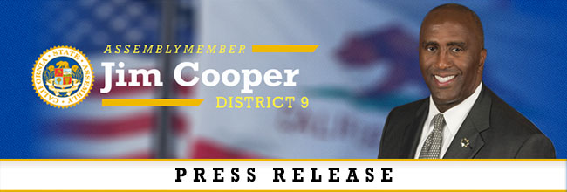
FOR IMMEDIATE RELEASE Contact: Skyler Wonnacott
January 9, 2018 (916) 319-2009

Serial Theft Prevention Legislation Fails in Key Committee
Bill would have fought organized theft crime rings and repeat offenders

SACRAMENTO – Assembly Bill 875, authored by Assemblymember Jim Cooper (D-Elk Grove), died today in the Assembly Public Safety Committee. The bill would have created a wobbler for persons who had a prior conviction for any serious or violent felony, and to any person who has three or more prior convictions for crimes such as petty theft, shoplifting, grand theft, or burglary. The bill would also authorize a court to grant deferred entry of judgment, for no less than 18 months and no longer than three years, to a defendant who has 3 or more prior convictions for those theft-related crimes. If passed by the Legislature, AB 875 would have only become affective when submitted to and approved by the voters at a statewide election.

“I am very disappointed in the Assembly’s Public Safety Committee for not recognizing that organized serial theft rings are targeting our mom and pop businesses,” said Assemblymember Jim Cooper. “Emboldened thieves will continue extort the law with no consequences, resulting in increased costs for day-to-day essentials for the middle-class and the poor.”

In 2014, theft‐related crimes involving property valued less than $950 were reduced to misdemeanors including shoplifting, commercial burglary, and check fraud. Since then, Californians have been directly impacted by a substantial increase in theft incidents committed by repeat offenders and organized crime rings.

“We are disappointed the Assembly Public Safety Committee did not pass AB 875 today. The measure would have provided much needed relief from the increasing losses that grocers and retailers across California are experiencing as a result of laws that enable criminals to steal up to $950 with no threat of a felony. Without a fix, grocers and retailers will suffer higher losses, employees will be put in harm’s way from increasingly violent thieves, and shoppers will ultimately pay the consequences at the register.”

AB 875 was co-sponsored by the California Grocers Association, California Police Chiefs Association and Crime Victims United California.

###

Assemblymember Cooper represents the Cities of Sacramento, Elk Grove, Galt and Lodi.

