TABLE OF CONTENTS

I. INTRODUCTION AND DISCLAIMER……………………………………………………….… 2
II. DISABILITY ACCESS LAW OVERVIEW………………………………...……..……………... 3
III. UNDERSTANDING YOUR OBLIGATIONS AS A LANDLORD OR A TENANT…………. 12
IV. PARKING, ACCESSIBLE ROUTES, AND PATHS OF TRAVEL –
GETTING IN THE DOOR…………………………………………………………………….. 13
V. ACCESSIBLE SIGNS…………………………………………………………………………... 17
VI. ACCESS TO MERCHANDISE AND STORE LAYOUT…………………………….………. 19
VII. RESTROOMS…………………………………………………………………………………. 24
VIII. TRANSACTION AND POINT OF SALE ISSUES……..…………………….…………….. 26
IX. SERVICE ANIMALS........................................................................................................ 28
X. COMMUNICATION ISSUES/AUXILIARY AIDS AND SERVICES………….…….……....... 35
XI. COMMON ISSUES ASSOCIATED WITH ADDITIONAL FEATURES AND SERVICES.… 37
XII. RECEIVING AND PROCESSING ACCESS COMPLAINTS……………………………….. 39
ADA TOOLKIT DISCLAIMER
The information and materials made available in this Toolkit have been prepared by Downey Brand for general informational purposes only and should not be construed as legal advice on any subject matter, or to answer specific legal problems you may have. No recipients of content from this Toolkit, clients or otherwise, should act or refrain from acting on the basis of any content included in the Toolkit without seeking appropriate legal or other professional advice on the particular facts and circumstances at issue from a licensed attorney. The Toolkit contains general information and may not reflect current legal developments, verdicts or settlements. Downey Brand expressly disclaims all liability with respect to actions taken or not taken based on any or all the contents of the Toolkit.

While Downey Brand has tried to ensure the accuracy of the information contained in the Toolkit, we cannot guarantee that all of the information is accurate. You should be aware that the law is constantly changing and varies by circumstance. Therefore, information on a given legal issue or the law may not be current or apply to your particular situation. You should not act or refrain from acting upon this information without seeking the advice of licensed professional counsel. Use of any of the information in the Toolkit does not create an attorney-client relationship between you and Downey Brand.

- INTRODUCTION AND DISCLAIMER
This Toolkit provides information and resources to help you make informed and compliant decisions regarding disability access issues in places of public accommodation, as addressed by Title III of the Americans with Disabilities Act and its associated regulations and various California laws.

By providing this Toolkit and the accompanying workshops, the California Grocers Association (CGA) and the CGA Educational Foundation (CGAEF) are providing an opportunity for CGA members and attendees to learn information regarding disability access issues that may be of interest to your company. The Toolkit and workshops are designed to provide practical and useful information on disability access issues. They do not cover other areas of access compliance, such as issues of disability access and accommodation related to commercial facilities or employees.
The Toolkit and workshops are not intended to be comprehensive or customized for your particular facilities or operations. Instead, they are intended to provide a starting point toward achieving disability access compliance for your company. To obtain a more customized Toolkit and/or assessment of your company’s compliance with disability access laws and regulations, you may contact Downey Brand, LLP directly.
About the Author:

Elizabeth B. Stallard is a partner at Downey Brand, LLP, licensed in both California and Nevada, and based in Downey Brand’s Sacramento office. Her practice focuses on labor and employment issues, and she counsels clients and litigates disputes involving federal and state employment laws, disability access, Cal/OSHA compliance, trade secrets, intellectual property, data privacy, and general business issues.

- DISABILITY ACCESS LAW OVERVIEW
  - The Americans with Disabilities Act of 1990
The starting point for any conversation about disability access or disability discrimination is the federal Americans with Disabilities Act of 1990, as amended (the “ADA”). The five Titles of the ADA address various rights of individuals with disabilities. This Toolkit focuses on Title III of the ADA, which, among other things, addresses the right of individuals with disabilities to be free from discrimination and to fully and equally enjoy public accommodations. (42 U.S.C. §§ 12181-12189.)

    - Public Accommodations
The ADA provides, in relevant part, that “[n]o individual shall be discriminated against on the basis of disability in the full and equal enjoyment of the goods, services, facilities, privileges, advantages, or accommodations of any place of public accommodation by any person who owns, leases (or leases to), or operates a place of public accommodation.” (42 U.S.C. § 12182(a).) A public accommodation is facility operated by a private entity whose operations affect commerce and fall within at least one of the following categories:

- An inn, hotel, motel, or other place of lodging;
- A restaurant, bar, or other establishment serving food or drink;
- A motion picture house, theater, concert hall, stadium, or other place of exhibition or entertainment;
- An auditorium, convention center, lecture hall, or other place of public gathering;
- A bakery, grocery store, clothing store, hardware store, shopping center, or other sales or rental establishment;
- A laundromat, dry-cleaner, bank, barber shop, beauty shop, travel service, shoe repair service, funeral parlor, gas station, office of an accountant or lawyer, pharmacy, insurance office, professional office of a health care provider, hospital, or other service establishment;
- A terminal, depot, or other station used for specified public transportation;
- A museum, library, gallery, or other place of public display or collection;
- A park, zoo, amusement park, or other place of recreation;
- A nursery, elementary, secondary, undergraduate, or postgraduate private school, or other place of education;
- A day care center, senior citizen center, homeless shelter, food bank, adoption agency, or other social service center establishment; and
- A gymnasium, health spa, bowling alley, golf course, or other place of exercise or recreation.

(42 U.S.C. § 12181(7); 28 C.F.R. § 36.104.) These categories are by no means exhaustive. Instead, and as the U.S. Supreme Court has explained, “the legislative history indicates [that categories of public accommodations] ‘should be construed liberally’ to afford people with disabilities ‘equal access’ to the wide variety of establishments available to the nondisabled [sic].” (PGA Tour, Inc. v. Martin, 532 U.S. 661, 676-77 [2001].)

As the list above confirms, and as is discussed in greater detail elsewhere in this Toolkit at Section XI, various additional facilities that are frequently provided in or adjacent to a grocery store, such as bank branches, dining areas, and coffee shops, are also public accommodations, and therefore also can support an effort to impose legal liability for failure to comply with the ADA or related California disability access laws.

    - Modifications in Policies, Practices, or Procedures.
Public accommodations must make reasonable modifications in policies, practices, or procedures, when the modifications are necessary to afford goods, services, facilities, privileges, advantages, or accommodations to individuals with disabilities, unless the public accommodation can demonstrate that making the modifications would fundamentally alter the nature of the goods, services, facilities, privileges, advantages, or accommodations. (28 C.F.R. § 36.302(a).) Two examples of such modifications are providing equivalent service to persons with mobility impairments at check-out aisles and admitting service animals into a place of public accommodation. These modifications are discussed in greater detail in Sections VIII and IX of this Toolkit, respectively.
    - Auxiliary Aids and Services
Auxiliary aids and services are devices or services that enable persons with impaired sensory, manual, or speaking skills to have an equal opportunity to participate in, and enjoy the benefits of, programs or activities. (28 C.F.R. § 39.103.) A public accommodation must take those steps that may be necessary to ensure that no individual with a disability is excluded, denied services, segregated or otherwise treated differently than other individuals because of the absence of auxiliary aids and services, unless the public accommodation can demonstrate that taking those steps would fundamentally alter the nature of the goods, services, facilities, privileges, advantages, or accommodations being offered or would result in an undue burden, i.e., significant difficulty or expense. (28 C.F.R. § 36.303(a).) Auxiliary Aids and Services are discussed in greater detail in Section X of this Toolkit.
    - Architectural Barriers in Existing Facilities.
The ADA provides that discrimination includes the failure to remove architectural barriers in existing facilities where such removal is readily achievable. (42 U.S.C. § 12182(b)(2)(A)(iv).) Architectural barriers are the physical elements of a facility that impede access by people with disabilities. Existing facilities were not explicitly defined under the prior 1991 ADA regulations, yet were understood to be those facilities in existence prior to applicability of the ADA. However, the 2010 amendments now define the term, explaining that an existing facility means a facility in existence on any given date, without regard to whether the facility may also be considered newly constructed or altered. (28 C.F.R. § 36.104.) Department of Justice guidance explains the meaning behind this new definition:

A newly constructed facility remains subject to the accessibility standards in effect at the time of design and construction, with respect to those elements for which, at that time, there were applicable ADA Standards. That same facility, however, after construction, is also an existing facility, and subject to the public accommodation's continuing obligation to remove barriers where it is readily achievable to do so.
(Appendix A to Part 36—Guidance on Revisions to ADA Regulation on Nondiscrimination on the Basis of Disability by Public Accommodations and Commercial Facilities, available at http://www.ada.gov/regs2010/titleIII_2010/titleIII_2010_regulations.htm#a101.)

All public accommodations must remove architectural barriers and communication barriers that are structural in nature in existing facilities when it is readily achievable to do so. The term facility includes all or any portion of buildings, structures, sites, complexes, equipment, rolling stock or other conveyances, roads, walks, passageways, parking lots, or other real or personal property, including the site where the building, property, structure, or equipment is located. (28 C.F.R. § 36.104.) Both temporary and permanent facilities are required to comply with the ADA.

“Readily achievable” means easily accomplishable and able to be carried out without much difficulty or expense. (42 U.S.C. § 12181(9); 28 C.F.R. § 36.104.) In determining whether an action is readily achievable, factors to be considered include:

- The nature and cost of the action needed;
- The overall financial resources of the site or sites involved in the action; the number of persons employed at the site; the effect on expenses and resources; legitimate safety requirements that are necessary for safe operation, including crime prevention measures; or the impact otherwise of the action upon the operation of the site;

- The geographic separateness, and the administrative or fiscal relationship of the site or sites in question to any parent corporation or entity;
- If applicable, the overall financial resources of any parent corporation or entity; the overall size of the parent corporation or entity with respect to the number of its employees; the number, type, and location of its facilities; and
- If applicable, the type of operation or operations of any parent corporation or entity, including the composition, structure, and functions of the workforce of the parent corporation or entity.

(28 C.F.R. § 36.104(1)-(5). See also 42 U.S.C. § 12181(9)(A)-(D).)

Examples of readily achievable steps to remove barriers include:

- Installing ramps;
- Making curb cuts in sidewalks and entrances;
- Repositioning shelves;
- Rearranging tables, chairs, vending machines, display racks, and other furniture;
- Repositioning telephones;
- Adding raised markings on elevator control buttons;
- Installing flashing alarm lights;
- Widening doors;
- Installing offset hinges to widen doorways;
- Eliminating a turnstile or providing an alternative accessible path;
- Installing accessible door hardware;
- Installing grab bars in toilet stalls;
- Rearranging toilet partitions to increase maneuvering space;
- Insulating lavatory pipes under sinks to prevent burns;
- Installing a raised toilet seat;
- Installing a full-length bathroom mirror;
- Repositioning the paper towel dispenser in a bathroom;
- Creating designated accessible parking spaces;
- Installing an accessible paper cup dispenser at an existing inaccessible
water fountain;
- Removing high pile, low density carpeting; or
- Installing vehicle hand controls.

(28 C.F.R. § 36.304(b).) To the extent a decision must be made with respect to which barriers should be addressed first, federal law even offers a ranking, or order of priority with respect to barrier removal. This is the priority public accommodations are urged to follow:

(1) First, a public accommodation should take measures to provide access to a place of public accommodation from public sidewalks, parking, or public transportation. These measures include, for example, installing an entrance ramp, widening entrances, and providing accessible parking spaces.

(2) Second, a public accommodation should take measures to provide access to those areas of a place of public accommodation where goods and services are made available to the public. These measures include, for example, adjusting the layout of display racks, rearranging tables, providing Brailled and raised character signage, widening doors, providing visual alarms, and installing ramps.

(3) Third, a public accommodation should take measures to provide access to restroom facilities. These measures include, for example, removal of obstructing furniture or vending machines, widening of doors, installation of ramps, providing accessible signage, widening of toilet stalls, and installation of grab bars.

(4) Fourth, a public accommodation should take any other measures necessary to provide access to the goods, services, facilities, privileges, advantages, or accommodations of a place of public accommodation.

(28 C.F.R. § 36.304(c).) Where a public accommodation can demonstrate that barrier removal is not readily achievable, the public accommodation must still make its goods, services, facilities, privileges, advantages, or accommodations available through alternative methods, if those methods are readily achievable. (28 C.F.R. § 36.305(a).) Examples of such alternatives include: providing curb service or home delivery; retrieving merchandise from inaccessible shelves or racks; and relocating activities to accessible locations. (28 C.F.R. § 36.305(b).)

    - Architectural Barriers in New Construction and Alterations
New construction is a facility designed and constructed for first occupancy after January 26, 1993. (28 C.F.R. § 36.401(a).) New construction must be readily accessible and usable by individuals with disabilities unless it is structurally impracticable to do so. (28 C.F.R. § 36.401(a), (c).) Structural impracticability is a hard test to meet, as it exists “only in those rare circumstances when the unique characteristics of terrain prevent the incorporation of accessibility features.” (28 C.F.R. § 36.401(c)(1).) Even in cases of structural impracticability, public accommodations have an obligation to comply with this obligation to the extent that it is not structurally impracticable. (28 C.F.R. § 36.401(c)(2).) For example, even if structural impracticability prevents making a public accommodation accessible to wheelchairs, accessibility must still be provided for persons with other kinds of disabilities.

Alterations to a place of public accommodation after January 26, 1992, shall be made so as to ensure that, to the maximum extent feasible, the altered portions of the facility are readily accessible to and usable by individuals with disabilities, including individuals who use wheelchairs. (28 C.F.R. § 36.402(a).) “Maximum extent feasible” applies in cases where “the nature of an existing facility makes it virtually impossible to comply fully with applicable accessibility standards through a planned alteration.” (28 C.F.R. § 36.402(c).) In such cases, the alteration shall provide the maximum physical accessibility feasible. (Id.)

    - Impact of Recent ADA Amendments
The ADA was amended by the ADA Amendments Act of 2008 (P.L. 110-325), which became effective on January 1, 2009. The Department of Justice then published revised final regulations implementing the ADA on September 15, 2010, including amendments related to Title III. These revised regulations contain new and updated requirements, including the 2010 Standards for Accessible Design (“2010 Standards”). All public accommodations must comply with the requirements of the 2010 ADA Standards, which include both the Title III regulations (28 C.F.R. Part 36) and the 2004 ADA Accessibility Guidelines (“2004 ADAAG”) (36 C.F.R. part 1191, appendices B and D).
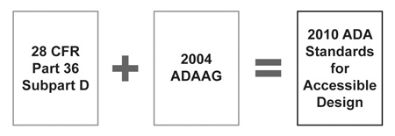
(Diagram illustrating the composition of the 2010 ADA Standards, available at http://www.ada.gov/regs2010/2010ADAStandards/2010ADAstandards.htm#pgfId-1010052.)

The 2010 Standards replace the 1991 Standards for Accessible Design (“1991 Standards”). The amendments also explain if, how, and when compliance must occur with respect to the 2010 Standards, as illustrated by the chart below.

Compliance Dates and Applicable Standards for Barrier Removal and Safe Harbor
(Appendix to 28 C.F.R. § 36.304(d))

Date | Requirement | Applicable Standards
Before March 15, 2012 | Elements that do not comply with the requirements for those elements in the 1991 Standards must be modified to the extent readily achievable.  Note: Noncomplying newly constructed and altered elements may also be subject to the requirements of § 36.406(a)(5). | 1991 Standards or 2010 Standards

Date | Requirement | Applicable Standards
On or after March 15, 2012 | Elements that do not comply with the requirements for those elements in the 1991 Standards or that do not comply with the supplemental requirements (i.e., elements for which there are neither technical nor scoping specifications in the 1991 Standards) must be modified to the extent readily achievable.  Note: Noncomplying newly constructed and altered elements may also be subject to the requirements of § 36.406(a)(5). | 2010 Standards
Elements not altered after March 15, 2012 | Elements that comply with the requirements for those elements in the 1991 Standards do not need to be modified. | Safe Harbor

  - State Laws Impacting Disability Access and Disability Discrimination
The State of California has also enacted various laws related to the prevention of disability discrimination. Laws of particular relevance to this Toolkit include:
    - The Unruh Civil Rights Act, Cal. Civ. Code § 51, et seq. (the “Unruh Act”).
The Unruh Act protects persons from discrimination by all business establishments in California, including public accommodations. (Cal. Civ. Code § 51(b).) The Unruh Act confirms that it does not impose an alteration obligation beyond that provided in other laws (such as the ADA):
“Nothing in this section shall be construed to require any construction, alteration, repair, structural or otherwise, or modification of any sort whatsoever, beyond that construction, alteration, repair, or modification that is otherwise required by other provisions of law, to any new or existing establishment, facility, building, improvement, or any other structure, nor shall anything in this section be construed to augment, restrict, or alter in any way the authority of the State Architect to require construction, alteration, repair, or modifications that the State Architect otherwise possesses pursuant to other laws.” (Cal. Civ. Code § 51(d).)

The Unruh Act also confirms that a violation of the right of any individual under the ADA shall also constitute a violation of the Unruh Act. (Cal. Civ. Code § 51(d).)
    - The California Disabled Persons Act, Cal Civ. Code § 54.1, et seq. (the “CDPA”).
The CDPA provides, in relevant part, that individuals with disabilities shall be entitled to full and equal access, as other members of the general public, to accommodations, advantages, facilities, medical facilities. (Cal. Civ. Code § 54.1(a)(1).) This includes hospitals, clinics, and physicians’ offices, and privileges of all common carriers, airplanes, motor vehicles, railroad trains, motorbuses, streetcars, boats, or any other public conveyances or modes of transportation (whether private, public, franchised, licensed, contracted, or otherwise provided), telephone facilities, adoption agencies, private schools, hotels, lodging places, places of public accommodation, amusement, or resort, and other places to which the general public is invited, subject only to the conditions and limitations established by law, or state or federal regulation, and applicable alike to all persons. (Id.)
    - Health and Safety Code § 19955, et seq.
These statutes obligate public accommodations and facilities that are constructed with private funds to comply with the requirements imposed by Government Code section 4450, et seq., which are nondiscrimination statutes triggered by the receipt of state funding or use of state funds for construction. (Cal. Health & Safety Code § 19955(a).)
    - The California Building Code
The California regulations known as the California Building Code contain comprehensive requirements regarding accessibility compliance. (2013 California Building Code, C.C.R. Title 24, Part 2, Volume 1, Chapters 10, 11A, and 11B.) California Building Code requirements sometimes differ from – and have on occasion even been in direct conflict with – federal accessibility requirements. However, and particularly in recent years, an effort has been made to keep state requirements consistent with federal law. Both the California Building Code and the ADAAG should be consulted when addressing any physical access issues.
    - Local and Municipal Laws, Regulations, and Ordinances
Some cities and counties have enacted their own laws, regulations, or ordinances related to disability discrimination and/or disability access, such as San Francisco’s service animal ordinance, described in Section IX. It is important that you familiarize yourself with any and all such laws, regulations, and ordinances so as to ensure that you are in compliance.
  - Enforcement of Disability Access Laws
Individuals can file an ADA disability discrimination complaint with the Department of Justice, or they can proceed with a private civil action in court. (42 U.S.C. § 12188(a)(1).) In cases where enforcement is pursued by the Attorney General, the Attorney General may commence a civil action with respect to the violation, and the court addressing that action may award injunctive relief, monetary damages, and civil penalties. (42 U.S.C. § 12188(b).)

In cases where the individual pursues a private civil action, the court may order injunctive relief, which includes an order to make a facility “readily accessible.” (42 U.S.C. § 12188(a)(2).) The court may also award attorney’s fees to the prevailing Plaintiff. (42 U.S.C. § 12188(a)(1).)

The ADA does not provide a right for a private plaintiff to obtain monetary damages for access violations. However, such damages may be recovered under California law. The usual basis for claims for access violation damages in California is the Unruh Act, which provides that a violating party may be subject to up to a maximum of three times the amount of actual damages, but in no case less than four thousand dollars ($4,000.00) per violation, as well as attorney’s fees. (Cal. Civ. Code § 52(a).)

In California, disability discrimination complaints associated with public accommodations may also be filed with the Department of Fair Employment and Housing (“DFEH”). The DFEH has the ability to litigate any such matters either before the Fair Employment and Housing Commission or in civil court, and may obtain all remedies available for civil violations.

- UNDERSTANDING YOUR OBLIGATIONS AS A LANDLORD OR A TENANT
  - Allocating the Obligation for Disability Access Compliance
Any person “who owns, leases (or leases to), or operates a place of public accommodation” that discriminates against an individual on the basis of disability is subject to liability under the ADA. (42 U.S.C. § 12182(a).) While tenants and landlords may allocate ADA compliance responsibility by lease or other contract (such as by confirming who is responsible for access compliance in common areas), such allocation is only effective as between the landlord and the tenant. (28 C.F.R. § 36.201(b).) In other words, notwithstanding the allocation of responsibility between a landlord and a tenant, an individual with a disability may pursue statutory claims against either the landlord or the tenant, or against both. (Botosan v. Paul McNally Realty, 216 F.3d 827, 833-34 (9th Cir. 2000).)

It is also important to understand that because of this joint liability, lease restrictions will likely not be an effective defense to an access violation claim. In Grove v. De La Cruz, 407 F.Supp.2d 1126 (C.D. Cal. 2005), the court confirmed that the proposed barrier removal was readily achievable, and that liability could therefore be imposed on a tenant even though the lease agreement prohibited the tenant from making physical alterations to the property. (Id. at 1133.)

  - What Should Be In Your Lease?
Although lease allocations will not prevent the imposition of liability by a third party, it is critical that landlords and tenants understand their access law obligations under their leases and perform accordingly, both to potentially avoid third party claims and to prevent disputes between landlord and tenant over a failure to comply with applicable obligations. Leases first entered prior to the ADA’s enactment may not contain any provisions addressing the obligation to comply with access laws. Even those leases first entered after the ADA’s enactment may fail to clearly and fully address who has the ability and the responsibility to ensure compliance with access laws.

California law requires commercial property owners or lessors to state on every lease form or rental agreement executed on or after July 1, 2013, whether the property being leased or rented has undergone inspection by a Certified Access Specialist (CASp), and, if so, whether the property has or has not been determined to meet all applicable construction-related accessibility standards pursuant to Civil Code section 55.53. (Cal. Civ. Code § 1938.) However, there is no form or required language for allocating access law responsibility, and leases allocate this responsibility in a myriad of ways. Both landlords and tenants should therefore ensure that they understand exactly what their own leases require, as well as understand what kind of obligations they have accepted given the condition and use of a particular facility.

- PARKING, ACCESSIBLE ROUTES, AND PATHS OF TRAVEL – GETTING IN THE DOOR
Perhaps the most common cause of third party lawsuits for access violations is the failure to provide compliant accessible parking and accessible routes. Common issues related to accessible parking and accessible routes are detailed below.
  - Parking
Where public parking spaces are provided, they must comply with ADAAG section 208 and CBC section 11B-208. Generally, the number of parking spaces a public accommodation is required to provide may be calculated based on the following chart.

ADAAG Table 208.2 Parking Spaces

Total Number of Parking Spaces Provided in Parking Facility | Minimum Number of Required Accessible Parking Spaces
1 to 25 | 1
26 to 50 | 2
51 to 75 | 3
76 to 100 | 4
101 to 150 | 5
151 to 200 | 6
201 to 300 | 7
301 to 400 | 8
401 to 500 | 9
501 to 1000 | 2 percent of total
1001 and over | 20, plus 1 for each 100, or fraction thereof, over 1000

In cases where six or fewer parking spaces are provided, the accessible space must be an accessible van parking space. (ADAAG 208.2.4; CBC 11B-208.2.4.) Accessible parking spaces that serve a particular building or facility must be located on the shortest accessible route from the parking to an accessible entrance. (ADAAG 208.3.1; CBC 11B-208.3.1.) Where parking serves more than one accessible entrance, accessible parking spaces must be dispersed and located on the shortest accessible route to the accessible entrances. (Id.) And where parking facilities do not serve a particular building or facility, such as a parking garage, accessible parking spaces shall be located on the shortest accessible route to an accessible pedestrian entrance of the parking facility. (Id.)

The specific technical requirements for accessible parking spaces are detailed in ADAAG Section 503 and CBC Section 11B-503. These requirements impose a myriad of obligations addressing the width of accessible parking spaces, the width and location of access aisles, slope requirements, vertical clearance requirements, striping and appearance requirements, and sign requirements. These requirements are detailed and extensive, and as mentioned above, often lead to lawsuits for access violations. Accordingly, the ADAAG and CBC should be reviewed to determine the particular accessible parking compliance requirements for your operations.
  - Accessible Routes
Subject only to specific exceptions defined in the applicable regulations, the general requirement is that at least one accessible route must be provided within a site from the accessible parking spaces and accessible passenger loading zones, public streets and sidewalks, and public transportation stops to the accessible building or facility entrance they serve. (ADAAG 206.2; CBC 11B-206.2.) When two or more arrival points serve the same accessible entrance or entrances, they all must be on accessible routes. (Id.)

ADAAG Figure 403.5.1 - Clear Width of an Accessible Route
(available at http://www.ada.gov/regs2010/2010ADAStandards/2010ADAstandards.htm#c4)

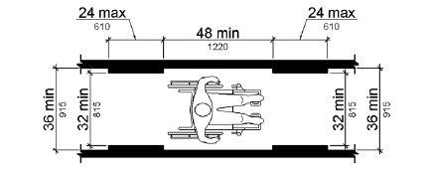

Accessible routes consist of one or more of the following components: walking surfaces with a running slope not steeper than 1:20, doorways, ramps, curb ramps excluding the flared sides, elevators, and platform lifts. (ADAAG 402.2; CBC 11B-402.2.) All components of an accessible route must comply with their applicable accessibility requirements. (Id.) The specific technical requirements for each component are provided in the following regulations:

Component | Applicable Regulations
Walking surfaces, including handrail requirements and passing spaces | ADAAG 403; CBC 11B-403
Doorways, including thresholds, door pressure, and maneuvering clearance requirements | ADAAG 404; CBC 11B-404

Component | Applicable Regulations
Ramps, including slopes and landings | ADAAG 405; CBC 11B-405
Curb ramps | ADAAG 406; CBC 11B-406
Elevators | ADAAG 407-08; CBC 11B-407-11B-408
Platform lifts | ADAAG 410; CBC 11B-410

  - Alterations and Paths of Travel

A “path of travel” includes a continuous, unobstructed way of pedestrian passage by means of which the altered area may be approached, entered, and exited, and which connects the altered area with an exterior approach (including sidewalks, streets, and parking areas), an entrance to the facility, and other parts of the facility. (28 C.F.R. § 36.403 (e)(1).) An accessible path of travel may consist of walks and sidewalks, curb ramps and other interior or exterior pedestrian ramps; clear floor paths through lobbies, corridors, rooms, and other improved areas; parking access aisles; elevators and lifts; or a combination of these elements. (28 C.F.R. § 36.403 (e)(2).) The term “path of travel” also includes the restrooms, telephones, and drinking fountains serving an altered area. (28 C.F.R. § 36.403(e)(3).) The CBC also confirms that the path of travel includes signs. (CBC 11B-202.4.)

Any alteration that affects or could affect the usability of or access to an area of a facility that contains a primary function must be made so as to ensure that, to the maximum extent feasible, the path of travel to the altered area and the restrooms, telephones, and drinking fountains serving the altered area, are readily accessible to and usable by individuals with disabilities, including individuals who use wheelchairs, unless the cost and scope of such alterations is disproportionate to the cost of the overall alteration. (28 C.F.R. § 36.403(a)(1).)

As an example, in the case of a grocery store, remodeling merchandise display areas would constitute a qualifying alteration, but altering windows, hardware, outlets, or signage would not. (28 C.F.R. § 36.403(c)(1)-(2).) This obligation will also not trigger solely because of an alteration to a primary function area served by a path of travel if the private entity has already constructed or altered required elements in accordance with the 1991 ADA Standards. (28 C.F.R. § 36.403(a)(2); CBC 11B-202.4.) In a number of cases, additions or alterations made to meet accessibility requirements will not trigger the path of travel obligation either. The qualifying alterations and additions are detailed in CBC 11B-202.4, Exceptions 3 and 4.
The overall cost of expenditures required to provide an accessible path of travel cost is disproportionate when it exceeds 20% of the cost of the alteration to the primary function area. (28 C.F.R. § 36.403(f)(1).) In such cases, the cost to comply with path of travel requirements shall be limited to 20 percent of the cost of the alteration, and the path of travel shall be made accessible to the extent possible in keeping with the following decreasing order of priority:
- An accessible entrance;
- An accessible route to the altered area;
- At least one accessible restroom for each sex or a single unisex restroom;
- Accessible telephones;
- Accessible drinking fountains; and
- When possible, additional accessible elements such as parking, storage, and alarms.

(28 C.F.R. § 36.403(g)(1)-(2); CBC 11B-202.4, Exception 8.) Additional requirements related the calculation of disproportionality, including which alterations shall be considered in determining whether the cost is disproportionate, are detailed in the regulations.

- ACCESSIBLE SIGNS

ADAAG Figure 703.7.2.1 International Symbol of Accessibility

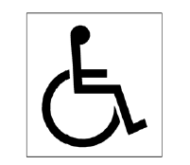

Providing accessible signs is part of a public accommodation’s obligation to remove structural communication barriers. Two sections of the ADAAG are the primary source of information regarding a public accommodation’s obligation to provide accessible signs. Generally speaking, ADAAG section 216, and the corresponding CBC section 11B-216, address which signs need to be accessible, and ADAAG section 703, and the corresponding CBC section 11B-703, detail the features of compliant signs.

Interior and exterior signs identifying permanent rooms and spaces must be accessible. (ADAAG 216.2; CBC 11B-216.2.) This obligation applies to signs that provide designations, labels, or names for interior rooms or spaces where the sign is not likely to change over time, such as interior signs labeling restrooms, room and floor numbers or letters, and room names. (Id.) However, this obligation does not extend to exterior signs that are not located at the door to the space they serve. (Id.)

Directional and informational signs, which provide direction to or information about interior spaces and facilities of a particular site, must also comply with ADAAG section 703 and CBC section 11B-703 requirements. (ADAAG 216.3; CBC 11B-216.3.) Signs in this category also include signs addressing rules of conduct, occupant load, and those signs identifying routes of egress. (Id.)

Signs providing direction to accessible means of egress, and doors at exit passageways, exit discharge, and exit stairways, must also be identified by tactile signs complying with ADAAG section 703 and CBC section 11B-703. (ADAAG 216.4.1, 216.4.3; CBC 11B-216.4.1, 11B-216.4.3.)

There are exceptions for certain kinds of signs, such as building directories, building addresses, and company names and logos. (ADAAG 216.1; CBC 11B-216.1.) There is also an exception for temporary (7 days or less) signs. (Id.) There are also particular requirements for parking signs, as addressed in Section IV of this Toolkit.

The regulations also detail when public accommodations are required to identify accessible areas. For example, if all entrances do not comply with accessible route requirements, the entrances that are accessible must be identified by the International Symbol of Accessibility (ADAAG Figure 703.2.1). (ADAAG 216.6; CBC 11B-216.6.) The non-compliant entrances must also be marked with accessible signs indicating the location of the nearest accessible entrance. (Id.) In such cases, the directional signs should be located to minimize backtracking, such as by locating the directional sign at the beginning of a particular route rather than just at the inaccessible entrance itself. (Id.) Other instances where signs are required to direct the public to accessible features, including accessible restrooms and check-out aisles, are addressed elsewhere within this Toolkit.

As referenced above, ADAAG section 703 and the corresponding CBC section 11B-703 identify the specific technical requirements that apply to accessible signs, including requirements for character spacing, height, font, case, and proportion, as well as requirements for raised characters, pictograms, and Braille. As illustrated by the following ADAAG table, the accessible sign requirements are both detailed and location dependent, and the ADAAG should be consulted to determine the particular compliance components for signs used in your business.

ADAAG Table 703.5.5 Visual Character Height
Height to Finish Floor or Ground  from Baseline of Character | Horizontal Viewing Distance | Minimum Character Height
40 inches (1015 mm)  to less than or equal to 70 inches (1780 mm) | less than 72 inches (1830 mm) | 5/8 inch (16 mm)
 | 72 inches (1830 mm) and greater | 5/8 inch (16 mm), plus 1/8 inch (3.2 mm) per foot (305 mm)  of viewing distance above 72 inches (1830 mm)
Greater than 70 inches (1780 mm)  to less than or equal to 120 inches (3050 mm) | less than 180 inches (4570 mm) | 2 inches (51 mm)
 | 180 inches (4570 mm) and greater | 2 inches (51 mm), plus 1/8 inch (3.2 mm) per foot (305 mm)  of viewing distance above 180 inches (4570 mm)
Greater than 120 inches (3050 mm) | less than 21 feet (6400 mm) | 3 inches (75 mm)
 | 21 feet (6400 mm) and greater | 3 inches (75 mm), plus 1/8 inch (3.2 mm) per foot (305 mm)  of viewing distance above 21 feet (6400 mm)

- ACCESS TO MERCHANDISE AND STORE LAYOUT
The information below is intended to address access to merchandise and store layout obligations frequently present in grocery stores. Importantly, and notwithstanding the requirements detailed below, the rearrangement of temporary or movable structures, such as furniture, equipment, and display racks, is not readily achievable to the extent that it results in a significant loss of selling or serving space. (28 C.F.R. § 36.304(f).)

  - Reach Ranges
ADAAG section 308, and its corresponding CBC section 11B-308, provide the applicable requirements for reach ranges. The applicable requirement is dictated by whether the reach is obstructed or unobstructed, as well as by whether the reach is forward or to the side.
ADAAG Figure 308.2.1 Unobstructed Forward Reach
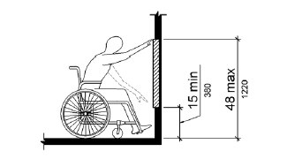

ADAAG Figure 308.2.2 Obstructed High Forward Reach

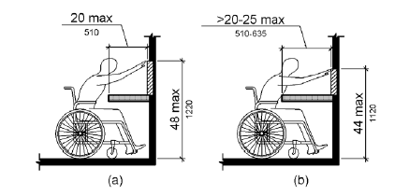

ADAAG Figure 308.3.1 Unobstructed Side Reach
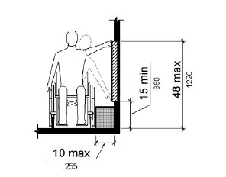

ADAAG Figure 308.3.2 Obstructed High Side Reach

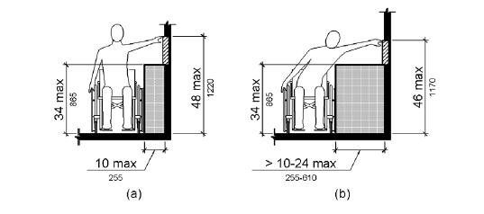

  - Operable Parts
Operable parts are a frequent consideration in public accommodations, as discussed elsewhere in this Toolkit. With respect to issues of access to merchandise, operable parts requirements are likely to arise with self-grinding coffee displays or other customer-operated devices.

Operable parts must be within a compliant reach range (ADAAG 309.3; CBC 11B-309.3) and must be in an area providing a compliant clear floor or ground space (ADAAG 309.2; CBC 11B-309.2). The operable parts themselves must be operable with one hand and must not require tight grasping, pinching or twisting of the wrist to operate. (ADAAG 309.4; CBC 11B-309.4) The force required to activate an operable part must also be no greater than 5 pounds. (Id.)

  - Self-Service Shelves and Dispensing Devices
Any self-service shelves and dispensing devices for tableware, dishware, condiments, food and beverages must comply with reach range requirements. (ADAAG 308; 904.5.1; CBC 11B-308; 11B-904.5.1.)

  - Use of Mobility Devices
A public accommodation must permit individuals with mobility disabilities to use wheelchairs and manually-powered mobility aids, such as walkers, crutches, canes, braces, or other similar devices designed for use by individuals with mobility disabilities in any areas open to pedestrian use. (28 C.F.R. § 36.311(a).)
As a result of the 2010 amendments, the ADA now also addresses the use of power-driven mobility devices that are not wheelchairs. An “other power-driven mobility device” is any mobility device powered by batteries, fuel, or other engines – whether or not designed primarily for use by individuals with mobility disabilities – that is used by individuals with mobility disabilities for the purpose of locomotion. (28 C.F.R. § 36.104.) This includes golf cars, electronic personal assistance mobility devices (EPAMDs), such as the Segway® PT, or any mobility device designed to operate in areas without defined pedestrian routes, but that is not a wheelchair within the meaning of the ADA. (Id.)
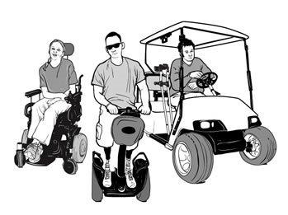
(image from U.S. Department of Justice, ADA Requirements For Wheelchairs, Mobility Aids, and other Power-Driven Mobility Devices, available at http://www.ada.gov/opdmd.htm.)
A public accommodation must make reasonable modifications in its policies, practices, or procedures to permit the use of other power-driven mobility devices by individuals with mobility disabilities, unless the public accommodation can demonstrate that the class of other power-driven mobility devices cannot be operated in accordance with legitimate safety requirements that the public accommodation has adopted pursuant to § 36.301(b). (28 C.F.R. § 36.311(b).) A public accommodation may assess the following five factors in order to determine whether any particular “other power-driven mobility device” can be allowed in a facility as a reasonable modification:
- The type, size, weight, dimensions, and speed of the device;
- The facility’s volume of pedestrian traffic (which may vary at different times of the day, week, month, or year);
- The facility’s design and operational characteristics (e.g., whether its business is conducted indoors, its square footage, the density and placement of stationary devices, and the availability of storage for the device, if requested by the user);
- Whether legitimate safety requirements can be established to permit the safe operation of the other power-driven mobility device in the specific facility; and
- Whether the use of the other power-driven mobility device creates a substantial risk of serious harm to the immediate environment or natural or cultural resources, or poses a conflict with Federal land management laws and regulations.
(28 C.F.R. § 36.311(b)(2)(i)-(v).) A public accommodation cannot ask an individual using a wheelchair or other power-driven mobility device questions about the nature and extent of the individual’s disability. (28 C.F.R. § 36.311(c)(1).) However, a public accommodation may ask a person using an other power-driven mobility device to provide a credible assurance that the mobility device is required because of the person’s disability. (28 C.F.R. § 36.311(c)(1).)
The federal regulations also confirm what constitutes a credible assurance for this purpose:
A public accommodation that permits the use of an other power-driven mobility device by an individual with a mobility disability shall accept the presentation of a valid, State-issued disability parking placard or card, or State-issued proof of disability, as a credible assurance that the use of the other power-driven mobility device is for the individual´s mobility disability. In lieu of a valid, State-issued disability parking placard or card, or State-issued proof of disability, a public accommodation shall accept as a credible assurance a verbal representation, not contradicted by observable fact, that the other power-driven mobility device is being used for a mobility disability. A “valid” disability placard or card is one that is presented by the individual to whom it was issued and is otherwise in compliance with the State of issuance’s requirements for disability placards or cards.
(28 C.F.R. § 36.311(c)(2).) ADA guidance encourages businesses to develop written policies specifying when other power-driven mobility devices will be permitted on their premises and to communicate those policies to the public. (ADA Update: A Primer for Small Business, available at http://www.ada.gov/regs2010/smallbusiness/smallbusprimer2010.htm.) In keeping with this advice, various California parks have developed policies identifying the other power-driven mobility devices that may be used within specific facilities and on specific trails. (See, e.g., http://ocparks.com/parks/trails/adaa.)

- RESTROOMS

If you provide restrooms for use by the public, you must comply with the ADAAG and CBC accessibility requirements for toilet facilities. (ADAAG 213.1; CBC 11B-213.1) Accessible toilet facilities must be provided on an accessible route from an accessible entrance. (ADAAG 206.2.2; CBC 11B-206.2.2.) Accessible restrooms are often the subject of third party lawsuits for access violations.

Where toilet compartments (i.e., stalls) are provided, at least one toilet compartment shall comply with wheelchair accessibility requirements. (ADAAG 213.3.1; CBC 11B-213.3.1.) When six or more toilet compartments are provided, or where the combination of urinals and water closets totals six or more fixtures, a public accommodation must also provide an additional accessible toilet compartment that is compliant with the ambulatory accessibility requirements of ADAAG 604.8.2 and CBC 11B-604.8.2. (Id.)

ADAAG Figure 604.2 Water Closet Location

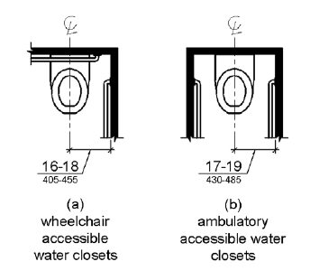

The regulations do provide certain exceptions to general requirements for alterations where it is technically infeasible to comply, as well as exceptions for multiple single user toilet rooms, whether permanent or temporary. (ADAAG 213.2; CBC 11B-213.2.) The regulations also detail specific requirements for unisex toilet rooms. (ADAAG 213.2.1; CBC 11B-213.2.1.)

Generally speaking, when a certain feature or fixture is provided in a toilet facility, at least one of that feature or fixture must be accessible. (See, e.g., ADAAG 213.3.2 and CBC 11B-213.3.2 (water closets), ADAAG 213.3.4 and CBC 11B-213.3.4 (lavatories), ADAAG 213.3.5 and CBC

11-B 213.3.5 (mirrors), and ADAAG 213.3.7 and CBC 11B-213.3.7 (coat hooks and shelves). However, there are exceptions. For example, an accessible urinal is not required unless more than one urinal is provided. (ADAAG 213.3.3; CBC 11B-213.3.3.)

When an existing restroom does not comply with accessibility requirements, directional signs compliant with accessibility requirements indicating the location of the nearest accessible restroom must be provided. (ADAAG 216.8; CBC 11B 216.8.) Where existing toilet rooms do not comply with accessibility requirements, those toilet rooms that do comply must be identified by the International Symbol of Accessibility. (Id.) Where clustered single user toilet rooms are permitted to use exceptions to ADAAG requirements, toilet rooms complying with ADAAG requirements shall be identified by the International Symbol of Accessibility unless all toilet rooms comply with ADAAG requirements. (Id.)

ADAAG section 603, and the corresponding CBC section 11B-603 identify the specific technical requirements that apply to accessible restrooms, including the requirements for water closets, urinals, grab bars, lavatories, dispensers, mirrors, sinks, coat hooks and shelves. The accessible restroom requirements are detailed, as well as feature and fixture dependent. The ADAAG and CBC should be consulted to determine the particular compliance requirements for public restrooms provided in your business.

- TRANSACTION AND POINT OF SALE ISSUES
The information below is intended to address transaction and point of sale obligations frequently present in grocery stores.

  - Check-Out Aisles and Sales and Service Counters
Check-out aisles and sales and service counters must comply with accessibility requirements. (ADAAG 904.1; CBC 11B-904.1.) Federal law requires that a store with check-out aisles ensure an adequate number of accessible check-out aisles are kept open during store hours, or otherwise modify its policies and practices in order to ensure that an equivalent level of convenient service is provided to individuals with disabilities as is provided to others. (28 C.F.R. § 36.302(d).)
Where more than one check-out aisle is provided, accessible check-out aisles complying must be identified by a compliant International Symbol of Accessibility. (ADAAG 216.11; CBC 11B-216.11.) Where check-out aisles are identified by numbers, letters, or functions, the signs identifying accessible check-out aisles must be located in the same location as the check-out aisle identification. (Id.) Such signs must also meet accessibility requirements. (Id.) However, if all check-out aisles serving a single function comply with accessibility requirements, no compliant International Symbol of Accessibility is required. (Id.)
If only one check-out aisle is accessible, and it is generally used for express service, one way of providing equivalent service is to allow persons with mobility impairments to make all their purchases at that aisle, regardless of number of items. (28 C.F.R. § 36.302(d).)
The particular technical requirements for accessible check-out aisles and sales and service counters are detailed in the ADAAG and CBC. (See, e.g., ADAAG 403, 904; CBC 11B-403, 11B-904.) These requirements address acceptable depths, lengths, and heights for counters and check-writing surfaces, as well as acceptable approach and clear floor or ground space requirements. Accessible check-out aisles and sales and service counters must also comply with applicable requirements for accessible walking surfaces, including the slope and width requirements. (ADAAG 403; CBC 11B-403.)

ADAAG Figure 904.3.2 Check-Out Aisle Counters
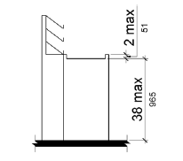
  - Point-of-Sale Devices
Federal law does not currently contain specific technical standards related to point-of-sale devices or tactile keypads. However, in 2004, California’s legislature passed AB 2312, which added provisions to California’s Financial Code regarding the accessibility features of point-of-sale devices. (Cal. Fin. Code § 13082, et seq.)
When point-of-sale devices are provided at check stands and sales and service counters, they must comply with CBC requirements pertaining to video touch screens and tactile keypads (11B-707.9.1), clear floor or ground space (CBC 11B-707.2), operable parts (CBC 11B-707.3), and privacy (CBC 11B-707.4).
  - Store Cards
Disabled individuals with vision impairments may have difficulties using store or other kinds of transaction cards, particularly given the recent trend toward eliminating the embossing (raised print) on such cards. Neither federal nor California law provides specific technical guidance regarding these cards. However, some card producers, such as banks, are already taking steps to offer accessibility accommodations, such as by offering the ability to request a card with raised print, or the ability to request a card with larger print or a notched edge (which also helps a person to distinguish between different transaction cards by feel). If your company issues store discount cards or any other form of transaction card, you should also evaluate and provide accessible options for disabled patrons.

- SERVICE ANIMALS
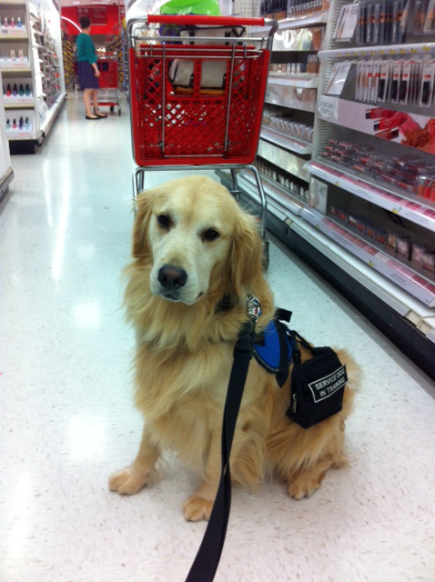

(image obtained at https://upload.wikimedia.org/wikipedia/commons/0/06/Service_dog_out_shopping.jpg)

  - What Is a Service Animal?
The ADA defines a service animal as any dog that is individually trained to do work or perform tasks for the benefit of an individual with a disability, including a physical, sensory, psychiatric, intellectual, or other mental disability. (28 C.F.R. 36.104.) California law offers a similar characterization, defining a service dog as any dog individually trained to the requirements of the individual with a disability, including, but not limited to, minimal protection work, rescue work, pulling a wheelchair, or fetching dropped items. (Cal. Civ. Code § 54.1(b)(6)(C)(iii).)

Service animals can perform any number of tasks for a person with a disability, including assisting individuals who are blind or have low vision with navigation and other tasks, alerting individuals who are deaf or hard of hearing to the presence of people or sounds, providing non-violent protection or rescue work, pulling a wheelchair, assisting an individual during a seizure, alerting individuals to the presence of allergens, retrieving items such as medicine or the telephone, providing physical support and assistance with balance and stability to individuals with mobility disabilities, and helping persons with psychiatric and neurological disabilities by preventing or interrupting impulsive or destructive behaviors. (28 C.F.R. § 36.104.)

Service animals in training are not considered service animals under federal law. However, California law is less restrictive, and provides that individuals training service animals – even if those individuals are not themselves disabled – may bring their trainee animals into any area in which a service animal would be permitted, and may do so with the same protections and privileges afforded to disabled individuals accompanied by service animals. (Cal. Civ. Code § 54.1(c).)

  - Miniature Horses
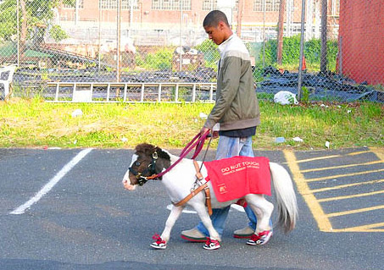

(image obtained at http://showhorsegallery.com/images/uploads/guidehorsemain.jpg.)

Although only dogs are defined as service animals under federal law, the 2010 amendments to the ADA include guidance regarding the use of miniature horses by persons with disabilities. In many respects the requirements are the same for miniature horses as they are for service animals: A public accommodation must make reasonable modifications in its policies, practices, or procedures to permit the use of a miniature horse by an individual with a disability if the miniature horse has been individually trained to do work or perform tasks for the benefit of the individual with a disability. (28 C.F.R. § 36.302(c)(9)(i).) However, the separate characterization of miniature horses was deliberate, in order to provide flexibility in situations where providing access for a miniature horse would not be appropriate.

For example, while there are no size or type restrictions with respect to what kind of dog may be a service animal, a public accommodation must consider the type, size, and weight of the miniature horse, and whether the facility can accommodate these features, when determining whether reasonable modifications can be made to allow access to a miniature horse. (28 C.F.R. § 36.302(c)(9)(ii)(A).) A public accommodation must also consider whether the handler has sufficient control of the horse, whether the horse is housebroken, and whether the horse’s presence in a specific facility compromises legitimate safety requirements that are necessary for safe operation. (28 C.F.R. § 36.302(c)(9)(ii)(B)-(D).)

Other provisions of the law that apply to service animals (such as the inquiry and access requirements detailed in this Toolkit) also apply to miniature horses. (28 C.F.R. § 36.302(c)(9)(iii).) Since federal law recognizes the use of miniature horses for this purpose, so does California.

  - What is Not a Service Animal?
Other species of animals, whether wild or domestic, trained or untrained, are not service animals. (28 C.F.R. § 36.104.)

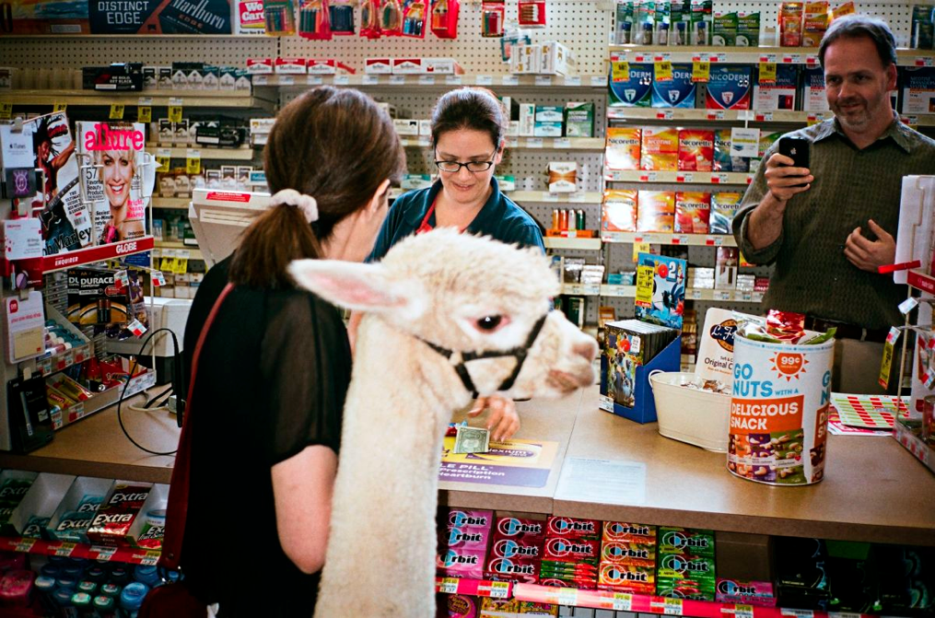

(image obtained at http://www.newyorker.com/wp-content/uploads/2014/10/141020_r25618-1200-796.jpg.)

Emotional support animals are not service animals either. An emotional support animal is a companion animal that provides some therapeutic benefit to an individual with a mental or psychiatric disability, but that is not trained to provide any particular tasks for the disabled person. (Auburn Woods I Homeowner’s Ass’n v. Fair Employment and Housing Com’n, 121 Cal. App. 4th 1578, 1595-96 (2004); Janush v. Charities Housing Development Corp., 169 F. Supp. 2d 1133, 1136 (N.D. Cal. 2000).) Both federal and California law provide certain specific protections with respect to emotional support animals (such as in housing and for travel on airplanes), but do not provide these animals access to general areas of public accommodation. As the ADA’s implementing regulations explicitly confirm, the provision of emotional support, well-being, comfort, or companionship do not constitute work or tasks for purposes of meeting the service animal definition. (28 C.F.R. § 36.104.)

Note: Some municipalities have enacted ordinances providing protections for emotional support animals. For example, San Francisco allows individuals with disabilities that use support animals equal access to all City-sponsored programs, facilities, services, and activities. Check local ordinances to make sure you know the legal requirements in the areas in which you operate.

  - Your Obligations With Respect to Service Animals
Under federal law, a service animal can go in all areas of a place of public accommodation where members of the public, program participants, clients, customers, patrons, or invitees, as relevant, are allowed to go. (28 C.F.R. § 36.302(c)(7).) California law provides an even more expansive definition regarding access for service animals, although for purposes of this Toolkit the key issue is providing access to all places where the public is invited. (Cal. Civ. Code § 54.1(a)(1).)

California law also provides additional guidance relevant to grocery stores, explaining that service animals may be allowed in areas that are not used for food preparation and that are usually open for consumers, such as dining and sales areas, if a health or safety hazard will not result from the presence or activities of the service animal and if the contamination of food, clean equipment, utensils, linens, and unwrapped single-use articles cannot result. (Cal. Health and Safety Code § 114259.5(b).)
Public accommodations have an obligation to make reasonable modifications in policies, practices, or procedures to permit the use of a service animal by an individual with a disability, unless making such modifications would fundamentally alter the nature of the goods, service, facilities, privileges, advantages, or accommodations. (28 C.F.R. § 36.302(c)(1).) An example of a reasonable modification is modifying a “no pets” policy to allow for the presence of service animals.
Your company cannot charge extra fees to individuals with service animals, isolate these people from your other patrons, or treat people with service animals less favorably than you would treat others. However, if your company normally charges customers for damage that they cause, an individual with a disability may be charged for damage caused by that individual’s service animal as well. (28 C.F.R. § 36.302(c)(8).)
Importantly, the law does not require that you supervise or care for anyone’s service animal. (28 C.F.R. § 36.302(c)(2).) This means that you do not have to provide food for the animal or a place for the animal to relieve itself. And if a service animal must be separated from an individual with a disability in order to avoid a fundamental alteration or a threat to safety, it is the responsibility of the individual with the disability to arrange for the care and supervision of the animal during that period of separation.

  - Service Animals and Shopping Carts
Prior federal guidance indicated more definitively that stores were not required to allow service animals to be placed in shopping carts. However, and no doubt as a result of the lawsuit captioned Butler v. Winco Foods, LLC, et al., District Court for the Central District of California Case No. 5:12-cv-00980-PA-DTB, which involved a seizure-detecting service animal that needed to be close to the individual’s face and could not reasonably be carried or placed in a chest pack (wearable dog carrier), this guidance has now been softened.
The current guidance provides as follows:
Q31. Are stores required to allow service animals to be placed in a shopping cart?
A. Generally, the dog must stay on the floor, or the person must carry the dog. For example, if a person with diabetes has a glucose alert dog, he may carry the dog in a chest pack so it can be close to his face to allow the dog to smell his breath to alert him of a change in glucose levels.
(Frequently Asked Questions about Service Animals and the ADA, available at http://www.ada.gov/regs2010/service_animal_qa.html.)
Based on this revised guidance, public accommodations should consider the appropriateness of a service animal riding in a shopping cart on a case-by-case basis, and certainly not rule it out entirely. Importantly, and while some disability-related websites encourage individuals to bring a blanket or other similar barrier in the event that a service animal will be riding in a shopping cart, individuals are not required to provide such items. Accordingly, your company may wish to consider having such items available, as well as a chest pack, for customers to borrow and use while on the premises.
  - What Do You Do When You Suspect an Animal May Not Be a Service Animal?
Sometimes it may be hard to tell that an animal is a service animal – or you may even suspect that someone is falsely representing that his or her animal is a service animal.

Service animals do not have to be registered or wear a particular identifying article of clothing. This is intended to protect the rights of the disabled, but has the unavoidable consequence of making it hard to easily verify the legitimacy of a particular service animal.

In situations where it is not readily apparent that an animal is a service animal, you may ask two questions:

- Is this animal required because of a disability?

- What tasks has the animal been trained to perform?
(28 C.F.R. § 36.302(c)(6).) Since it is not legally required, you cannot ask for proof of registration or certification as a service animal. You also cannot ask the individual about his or her disability, or ask for the service animal to demonstrate the task for which the animal has been trained.

You should not ask these two questions in cases where it is readily apparent that the animal is a service animal, such as when a visually-impaired person enters your facility with a guide dog. (28 C.F.R. § 36.302(c)(6).) In light of this provision, a policy that required company personnel to ask every person with a service animal to respond to these questions would likely be deemed discriminatory.

In recent years, and in response to apparent increases in people falsely claiming that their dogs are service animals in order to bring them into places that pets would not otherwise be allowed, businesses have tried to deter such deception by members of the public. For example, some businesses have added language to signs addressing the admittance of service animals referencing the potential legal consequences of falsely representing that an animal is a service animal. An example of one such sign is below.

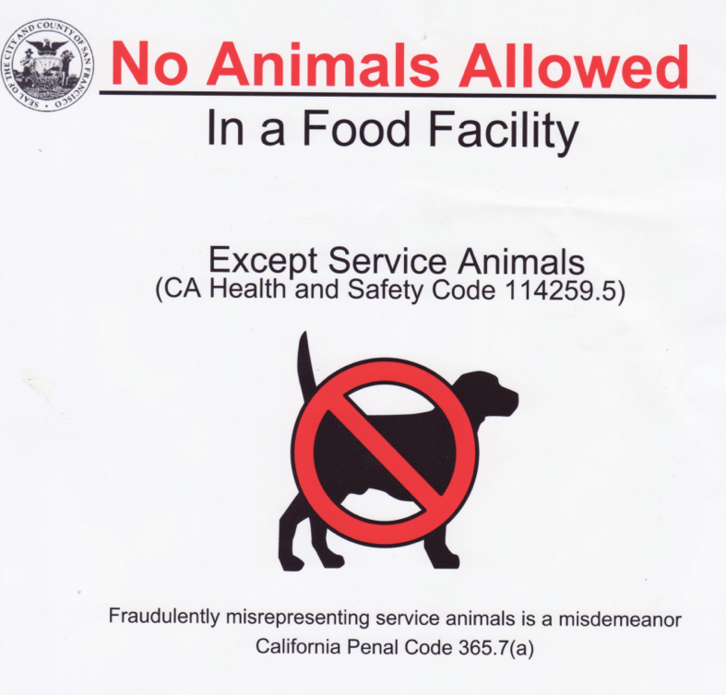

(Image obtained at http://media.nbcbayarea.com/images/No+Dog+Sign.jpeg.)

In addition to being a misdemeanor, California Penal Code section 365.7(a) provides for the imposition of a fine of up to $1,000 for such violations. Some businesses believe that including a reference to the Penal Code in their signs has helped to deter false service animal claims.

Importantly, disabled individuals are also concerned about false service animal claims. Untrained pets or emotional support animals can distract or even cause harm to true service animals – that are trained to be submissive and need to concentrate on their required tasks in order to be effective.

  - When Can You Exclude a Service Animal?
A public accommodation may ask an individual with a disability to remove a service animal from the premises if:
- The animal is out of control and the animal’s handler does not take effective action to control it; or
- The animal is not housebroken.
(28 C.F.R. S 36.302(c)(2).) Under control means that a service animal must have a harness, leash, or other tether, unless either the handler is unable because of a disability to use a harness, leash, or other tether, or the use of a harness, leash, or other tether would interfere with the service animal´s safe, effective performance of work or tasks, in which case the service animal must be otherwise under the handler’s control (e.g., voice control, signals, or other effective means). (28 C.F.R. S 36.302(c)(4).) For example, it would be permissible for a person in a wheelchair to utilize a retractable leash so that his or her accompanying service dog could travel distances to pick things up.
Under control also means that a service animal should not be allowed to bark repeatedly in a lecture hall, theater, library, or other quiet place. (Frequently Asked Questions about Service Animals and the ADA, available at http://www.ada.gov/regs2010/service_animal_qa.html.)
If a service animal is properly excluded, the public accommodation must still give the person with a disability the opportunity to obtain goods, services, and accommodations without having the service animal on the premises. (28 C.F.R. S 36.302(c)(3).)

- COMMUNICATION ISSUES /AUXILIARY AIDS AND SERVICES
  - General Obligations

A public accommodation must take those steps that may be necessary to ensure that no individual with a disability is excluded, denied services, segregated or otherwise treated differently than other individuals because of the absence of auxiliary aids and services, unless the public accommodation can demonstrate that taking those steps would fundamentally alter the nature of the goods, services, facilities, privileges, advantages, or accommodations being offered or would result in an undue burden, i.e., significant difficulty or expense. (28 C.F.R. § 36.303(a).)

The ADA requires that public accommodations provide appropriate auxiliary aids and services so as to ensure effective communication with individuals with hearing, speech, or vision impairments. (28 C.F.R. § 36.303(c)(1).) Examples of auxiliary aids include: qualified interpreters, assistive listening devices, notetakers, written materials, qualified readers, taped texts, and Brailled or large print materials. (28 C.F.R. § 36.303(b).)

The type of auxiliary aid or service necessary to ensure effective communication will vary based on such factors as: the method of communication used by the individual; the nature, length, and complexity of the communication involved; and the context in which the communication is taking place. (28 C.F.R. § 36.303(c)(1)(ii).) You should consult with individuals with disabilities whenever possible to determine what type of auxiliary aid is needed to ensure effective communication with them, but the ultimate decision as to what measures to take rests with you, provided that the method chosen results in effective communication. (Id.) In order to be effective, auxiliary aids and services must be provided in accessible formats, in a timely manner, and in such a way as to protect the privacy and independence of the individual with a disability. (Id.)

If the provision of a particular auxiliary aid or service by a public accommodation would result in a fundamental alteration in the nature of the goods, services, facilities, privileges, advantages, or accommodations being offered or result in an undue burden (i.e., significant difficulty or expense), the public accommodation must provide an alternative auxiliary aid or service, if one exists, that would not result in an alteration or such burden but would nevertheless ensure that, to the maximum extent possible, individuals with disabilities receive the goods, services, facilities, privileges, advantages, or accommodations offered by the public accommodation. (28 C.F.R. § 36.303(g).)
  - Common Issues With Auxiliary Aids and Services
Public accommodations should evaluate all ways in which they communicate with the public in order to ensure they are providing appropriate auxiliary aids and services to persons with disabilities. Specific modes of communication that may be relevant to grocery store operations are also addressed in greater detail below.

    - Telecommunications
Telecommunications include communications with live persons, such as call centers and customer service lines. Telecommunications also include automated-attendant systems, including voicemail and messaging, and interactive voice response systems for receiving and directing incoming telephone calls. Specific requirements for accessible telecommunication services are detailed in the federal regulations. (28 C.F.R. § 36.303(d).)
    - Websites
The ADA regulations do not currently contain requirements for the accessibility of website information. However, the Department of Justice is considering the adoption of standards for website accessibility, and it is anticipated that such standards will ultimately be adopted. In the meantime, Department of Justice guidance provides useful insight regarding ways to incorporate accessible features on websites, and should be consulted to identify and correct potential areas of noncompliance. (See, e.g., Website Accessibility Under Title II of the ADA, available at http://www.ada.gov/pcatoolkit/chap5toolkit.htm.)

- COMMON ISSUES ASSOCIATED WITH ADDITIONAL FEATURES AND SERVICES
The following are additional issues and requirements related to features and services commonly provided in or adjacent to grocery stores.
  - Dining and Work Areas
Dining areas include, but are not limited to, bars, tables, lunch counters, and booths. Work areas include writing surfaces, baby changing and other tables or fixtures for personal grooming, and coupon counters. (ADAAG 902.1; CBC 11B-902.1.)
Any dining or work areas provided in a place of public accommodation, including must comply with requirements related to clear floor or ground space (including knee and toe clearance), and requirements for the height of dining or work surfaces. (ADAAG 902.2, 902.3; CBC 11B-902.2, 11B-902.3.) As in various other areas of the ADA, there are also particular requirements for such areas provided for children’s use. (ADAAG 902.4; CBC 11B-902.4.)

  - Trash Cans or Other Collection Bins
Where provided, at least one of each type provided at each location must comply with clear floor or ground space, height/reach range requirements, and operable parts requirements. (ADAAG 811.2-811.4; CBC 11B-8.11.2-11B-8.11.4.)

  - Automatic Teller Machines (ATMs)
Where provided, at least one of each type provided at each location must comply with applicable requirements. (ADAAG 220.1; CBC 11B-220.1.) These requirements include clear floor or ground space requirements (ADAAG 707.2; CBC 11B-707.2) and operable parts requirements (ADAAG 707.3; CBC 11B-707.3), as well as various specific requirements specifically related to the use of an ATM, including: privacy requirements (ADAAG 707.4; CBC 11B-707.4); speech output and audible tone requirements (ADAAG 707.5; CBC 11B-707.5); input control requirements (ADAAG 707.6; CBC 11B-707.6); display screen requirements (ADAAG 707.7; CBC 11B-707.7); and Braille instruction requirements (ADAAG 707.8; CBC 11B-707.8).

Accessible ATMs, including those with speech and those that are within reach of people who use wheelchairs, must provide all the functions provided to customers at that location at all times. (ADAAG 220.1; CBC 11B-220.1.) For example, compliance is not satisfied if the accessible ATM only provides cash withdrawals while inaccessible ATMs also sell stamps or tickets.

  - Kiosks
There are no regulatory requirements specifically addressing kiosks, including such things as movie rental kiosks and kiosks that dispense lottery tickets or change. However, there have nonetheless been lawsuits filed against businesses that utilize these features. For example, in February of 2015, Redbox, which provides video rental kiosks, settled the class action captioned Lighthouse for the Blind and Visually Impaired, et al. v. Redbox Automated Retail LLC, et al., Northern District of California Case No. 4:12-cv-00195, which alleged that the Redbox kiosks failed to meet access requirements for blind and visually-impaired users. As part of the settlement, which also included a $1.2 million dollar class award, Redbox agreed to make changes to both its kiosk interface and its website to improve accessibility for visually impaired persons.
The takeaway from this and other similar lawsuits is clear: even though no specific technical requirements exist, public accommodations should evaluate such features on their own premises to determine accessibility issues and take steps to mitigate them when possible – even if that may mean removing such features until the associated vendor comes into compliance.

- RECEIVING AND PROCESSING ACCESS COMPLAINTS
  - Procedures For Handling Complaints
Quick and effective responses to disability access complaints may help avoid legal liability as well as support customer service goals. Accordingly, all public accommodations should have a policy and practice for handling complaints regarding disability access. Public accommodations should also provide training to all personnel regarding applicable disability access requirements and how to respond to disability access requests and complaints.

Having a designated individual or individuals responsible for disability access issues is an effective approach to managing access compliance. Logging and tracking all access complaints and the resolution of those complaints is also critical, both to identify access deficiencies and to identify individuals who may ultimately seek legal remedies for an access violation.

  - Certified Access Specialist (CASp) Evaluations
The Certified Access Specialist (CASp) program was created by Senate Bill 262 in 2003. The CASp program allows individuals to become certified to inspect buildings and sites for compliance with applicable state and federal construction-related accessibility standards. California’s Division of the State Architect provides a list of all CASp certified individuals on its website, which is available at:https://www.apps2.dgs.ca.gov/dsa/casp/casp_certified_list.aspx.

Other design professionals can also competently evaluate buildings and other facilities for access compliance, such as architects and engineers. However, having your facility evaluated by a CASp-certified individual also provides the ability to invoke certain protections under California law that may be valuable in the event you are later sued for access violations.

California Senate Bill 1608, passed in 2008, created the Construction-Related Accessibility Standards Compliance Act (CRASCA, Civil Code §§ 55.51-55.545). CRASCA provides, in relevant part, that if a business or property owner authorizes the inspection of a facility by a CASp, receives a CASp inspection report prior to being served a lawsuit for violation of a construction-related accessibility standard, and makes accessibility improvements to come into compliance according to the schedule provided with the CASp inspection report, the business or property owner receives “qualified defendant” status. (Cal. Civ. Code § 55.52 (a)(8).) Upon being served with a summons and complaint asserting a construction-related accessibility claim, including claims brought under the Unruh Act and CDPA, a qualified defendant may file a request for a court stay and early evaluation conference, tolling the deadline to respond to the complaint, and potentially providing the opportunity to resolve the litigation before significant costs are incurred. (Cal. Civ. Code 55.54 (b)(1).) Civil Code section 55.54 also provides a potential reduction in the statutory damages amount for identified violations. (Id.)

  - What Should You Do if You Have Been Served With a Complaint?
Since attorneys for successful ADA plaintiffs may recover their attorney’s fees, and due to the highly technical nature of access requirements (which makes them easy to violate, even when a public accommodation has tried to comply), public accommodations are often in a difficult situation when it comes to litigating lawsuits alleging access violations. The damages associated with access violations are relatively low, but the risk of paying a plaintiff’s attorney’s fees – and the potential size of that attorney fee award – is significant. Moreover, while recent changes in California law like CRASCA have offered additional protections to public accommodations defending against access lawsuits, in some cases these protections must be invoked very quickly, or they cannot be invoked by all public accommodations. (Cal. Civ. Code § 55.54.)

Accordingly, if you are served with a civil complaint, the first step should be to determine whether you have liability and the potential scope of that liability, whether with the assistance of counsel or on your own. Making this determination early – which is often easy to do, particularly in cases of architectural violations – will help you to make an appropriate business decision regarding how, or even whether, to proceed with litigation. Of course, you will also want to move quickly in order to determine whether you can take advantage of any of the protections provided by California law.

In the case of agency-related complaints (whether originating with the DOJ or the DFEH), the best approach is to contact counsel first, who can advise you with respect to the various steps associated with defending against and resolving such complaints in an administrative process.

  - What Should You Do Even if You Have Not Been Served With a Complaint?
The obligation of a public accommodation to provide access to persons with disabilities is continuing and ongoing. You must therefore always consider disability access issues when changing or designing features in your facilities, or when deciding to add or alter the services provided within them.

Please note that in an effort to address only those laws with likely relevance to the reader’s operations, nondiscrimination statutes triggered by a private entity’s receipt of federal funding (The Rehabilitation Act of 1973, 29 U.S.C. § 794, et seq.), or triggered by the receipt of state funding or use of state funds for construction (California Government Code §§ 4450 and 11135), are not addressed within this Toolkit.
Communication barriers that are structural in nature are barriers that are an integral part of the physical structure of a facility, such as conventional signage, which generally is inaccessible to people who have vision impairments, and audible alarm systems, which are inaccessible to people with hearing impairments. (Title III Technical Assistance Manual at III-4.4100, available at http://www.ada.gov/taman3.html.) The obligation to remove structural communication barriers is distinct from the obligation to provide auxiliary aids and services, such as assistive listening devices.
“Elements that have not been altered in existing facilities on or after March 15, 2012, and that comply with the corresponding technical and scoping specifications for those elements in the 1991 Standards are not required to be modified in order to comply with the requirements set forth in the 2010 Standards.” (28 C.F.R. § 36.304(d)(2)(i).)
28 C.F.R. § 36.301(b) provides that a “public accommodation may impose legitimate safety requirements that are necessary for safe operation. Safety requirements must be based on actual risks and not on mere speculation, stereotypes, or generalizations about individuals with disabilities.”

